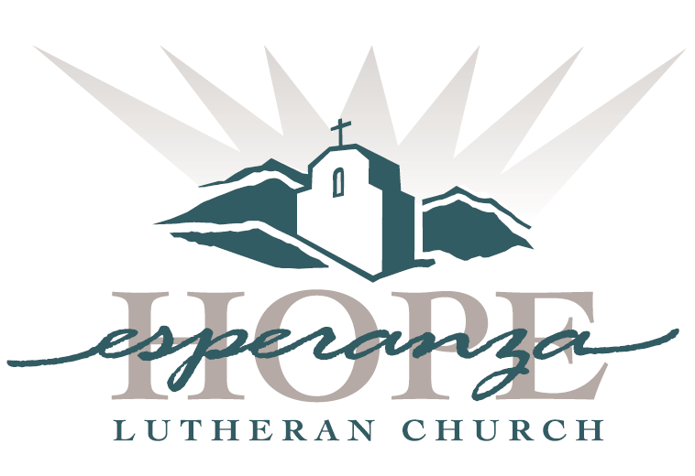

Blue Christmas
Thoughts on COVID
December 16, 2020

Welcome, Blessing of Service
Pastor Paul Campbell

Poem – “Night Thoughts”
Alice Schultze

The Year of COVID-19
Susan Vega

Poem – “Blues”
Alice Schultze

The Memories We Did Not Make
Elizabeth Farquhar

Music: Music - “Mirie it is while sumer ilast”
Anonymous England
Early 13th c.
Sung by James Nelson

Loved Ones Lost
Pastor Campbell

Poem – “Sunday in a Time of Virus”
Alice Schultze

Deliverance
Ray and Joyce Purdy

Poem – “Glory in a Time of Virus”
Alice Schultze

Gifts, Even Now
Craig Peck

Music: Full Fathom Five Thy Father Lies
From The Tempest Act 1 Scene 2
Written by - William Shakespeare
Composer - Robert Johnson
circ. 1610Sung by James Nelson

Blessing
Pastor Campbell

