The Eleventh Sunday After Pentecost
August 16, 2020
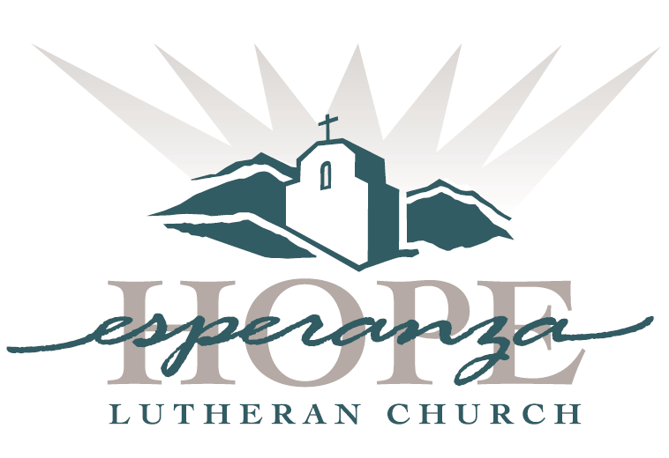

Welcome to new visitors and old friends; to believers, questioners, and questioning believers. Welcome to all people: any shape, size, color, culture, gender, age, ability, sexuality, and family type.
We give thanks for the diversity of God’s family and our unity as God’s people. This is a safe place for celebration, healing, rejoicing and renewal.

Order of Service

Welcome
Confession and Forgiveness
Most merciful God, we confess that we are captive to sin
and cannot free ourselves.
We have sinned against you in thought, word and deed,
by what we have done and what we have left undone.
We have not loved you with our whole heart; we have not love our neighbors as ourselves.
For the sake of your Son, Jesus Christ, have mercy on us.
Forgive us, renew us, and lead us, so that we may delight in your will
and walk in your ways, to the glory of your holy name. Amen

Gathering Song
“Come to the Table”
Prayer of the Day
Scripture
Isaiah 56:1, 6-8
Psalm 67:1-7
Romans 11: 1-2a, 29-32
Matthew 15: 10-28

Sermon
“Blessed”
The Apostle’s Creed
I believe in God, the Father almighty,
creator of heaven and earth.
I believe in Jesus Christ, God’s only Son, our Lord,
who was conceived by the Holy Spirit,
born of the virgin Mary,
suffered under Pontius Pilate,
was crucified, died, and was buried;
he descended to the dead.*
On the third day he rose again;
he ascended into heaven,
he is seated at the right hand of the Father, and
he will come to judge the living and the dead.
I believe in the Holy Spirit,
the holy catholic church,
the communion of saints,
the forgiveness of sins,
the resurrection of the body,
and the life everlasting. Amen.

Prayers of Intercession

The Lord’s Prayer
Our Father in heaven, hallowed be your name, your kingdom come,
your will be done, on earth as in heaven.
Give us today our daily bread.
Forgive us our sins as we forgive those who sin against us.
Save us from the time of trial and deliver us from evil.
For the kingdom, the power, and the glory are yours, now and forever. Amen.

Benediction
Closing Song
“Do Justice”
———————————————————————————————————————

Worship Leaders
David Coste – Musician
Liz Farquhar – Scripture
Pastor Paul Campbell

