The Tenth Sunday After Pentecost
August 9, 2020
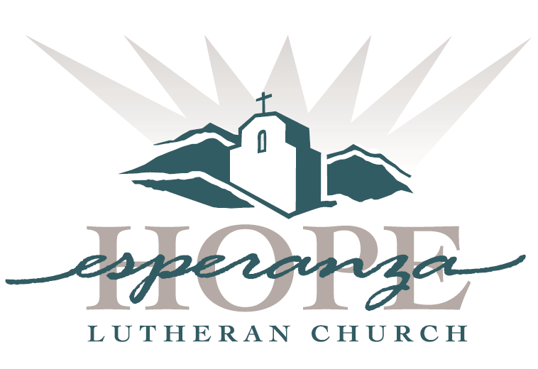

Welcome to new visitors and old friends; to believers, questioners, and questioning believers. Welcome to all people: any shape, size, color, culture, gender, age, ability, sexuality, and family type.
We give thanks for the diversity of God’s family and our unity as God’s people. This is a safe place for celebration, healing, rejoicing and renewal.

Order of Service

Welcome

Gathering Song
“Reckless Love”

Prayer of the Day

Scripture
Genesis 37: 1-4, 12-28
1 Kings 19: 9-18
Romans 10: 5-15
Matthew 14: 22-33

Sermon
“Response to Entitlement”

The Apostle’s Creed
I believe in God, the Father almighty,
creator of heaven and earth.

I believe in Jesus Christ, God's only Son, our Lord,
who was conceived by the Holy Spirit,
born of the virgin Mary,
suffered under Pontius Pilate,
was crucified, died, and was buried;
he descended to the dead.*
On the third day he rose again;
he ascended into heaven,
he is seated at the right hand of the Father, and
he will come to judge the living and the dead.
I believe in the Holy Spirit,
the holy catholic church,
the communion of saints,
the forgiveness of sins,
the resurrection of the body,
and the life everlasting. Amen.

Prayers of Intercession

The Lord’s Prayer
Our Father in heaven, hallowed be your name, your kingdom come,
your will be done, on earth as in heaven.
Give us today our daily bread.
Forgive us our sins as we forgive those who sin against us.
Save us from the time of trial and deliver us from evil.
For the kingdom, the power, and the glory are yours, now and forever. Amen.

Benediction

Closing Song
“Because of Your Love”

---------------------------------------------------------------------------------------------------------------------

Worship Leaders
Brooklyn and Riley Hanania – Musicians
Bryan Hanania – Scripture
Pastor Paul Campbell

